Adaptive Staircase Method
PSY310 Lab in Psychology
30th September 2026
Vridhi G Jain
AU2420124

GitHub Link:
Introduction:
The adaptive staircase method is an algorithm which adjusts the stimuli on-line according to the subject/participants performance. The subject is presented with a continuous sequence of the respected stimuli. The intensity of the following stimuli is either increased or decreased based on the subjects previous response. This helps in measuring the subject’s sensory threshold for that particular stimulus (Hailing, 2024). It is an extremely efficient method since it requires rather fewer stimuli when compared to other psychophysics methods – once the first few stimuli are out of the way, all the other stimuli are near the threshold-level (Dixon & Massey, 1957). The difference threshold, or Just Noticeable Difference (JND) is the smallest change in a stimulus that a person can reliably detect. In the following study, it is the smallest tilt of a grating that the participant can discriminate against (Lasky, 2019).

Method:

Participant
The participant is a 21-year old female undergraduate student at Ahmedabad University. Prior consent to participate in the study was taken and confidentiality was established. She was informed of the aim of the study.

Materials and Procedure
The study was conducted using PsychoPy v2026.2.3 on a laptop with a dimension of 14 inches with a resolution 1920x1200 pixels and a refresh rate of 60 Hz. The procedure aimed to evaluate the participants ability to identify the tilt direction. This was done by conducting 100 trials.

The participant was shown with a fixation presented for 500 milliseconds. After the aforementioned, a sinusoidal shape with a Gaussian mask appeared for 300 milliseconds. The grating on the shape was allocated left or right randomly at the start of the trial and the response to the same was done using either the left arrow key for left-tilted grating or the right arrow key for right-tilted grating.

The tilt of the grating was determined by the adaptive staircase. It started at 0.5 degrees and was adjusted according to the participants' response, with step sizes of 2, 1, 3 and 0.5 degrees. The responses were collected using PsychoPy. The reaction time, threshold and accuracy were recorded and saved to an Excel file.


Figure 1 – Stimuli, sinusoidal shape with a Gaussian mask with a right tilt

Results:
The difference threshold being 0.5 (average of the final five 1 to 0 reversals) shows that at this intensity, the participant could no longer detect the tilt of the stimulus. Additionally, the participant responded with a 76% accuracy over 100 trials. The participant was most accurate at the highest intensity (92%) and the lower accuracy is at 0.5 (62%). The mean reaction time across the trials was 0.5 seconds.

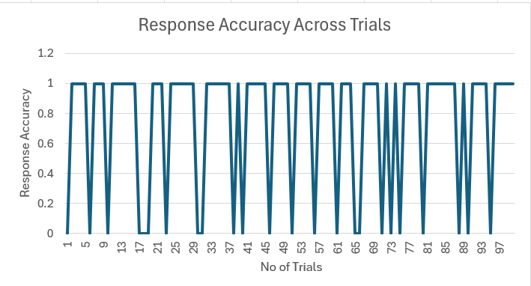
Figure 2: Response accuracy across trials

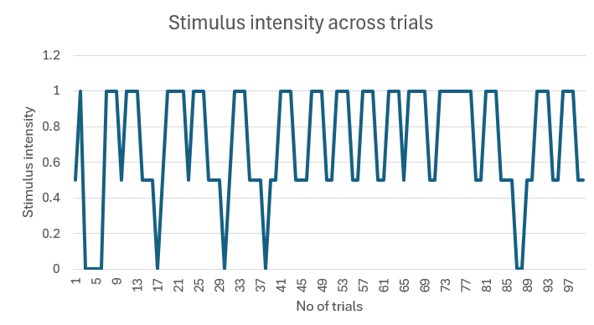
Figure 3: Stimulus intensity across trials

Discussion:
Since the threshold value was 0.5 degrees, the participant could detect the tilt of the stimulus to a small angular difference, about half a degree, indicating good sensitivity to the stimulus. An accuracy of 76% is a fairly moderate performance, It was the highest at the largest intensity (92% at 1 degree) and lowest at the smaller intensity (62% at 0.5 degrees). This pattern shows that the performance is dependent on the size of the tilt. The latter trials were around 0.5 and 1 degree, showing that the staircase has adjusted according to the participants threshold. However, the threshold obtained in the experiment should be considered with caution due to it not being conducted in the lab, causing other external factors to interfere with the result – lowering validity.

References

Dixon, W., & Massey, F. (1957). Notes and discussions the staircase-method in psychophysics. 35, 286. https://escholarship.org/content/qt89s1w9zb/qt89s1w9zb_noSplash_57320201c62122a123aebee98b47272d.pdf

Hailing, W. (2024). Staircase method. The ECPH Encyclopedia of Psychology, 1448–1449. https://doi.org/10.1007/978-981-97-7874-4_861

Dixon, W., & Massey, F. (1957). Notes and discussions the staircase-method in psychophysics. 35, 286. https://escholarship.org/content/qt89s1w9zb/qt89s1w9zb_noSplash_57320201c62122a123aebee98b47272d.pdf

